Fabric End-to-End Pipeline For ETL Implementation:

SSIS Equivalent Fabric pipeline activities:
- If Condition = Conditional Split in SSIS
- Script Activity = Execute SQL Task/OLE DB Command (runs any DML/DDL on our Database directly)
- Lookup Activity = Lookup Transformation (SELECT only, read-only – cannot run UPDATE statements like Script Activity)
- Copy Data = OLE DB Source + OLE DB Destination
- Dataflow Gen2 = Derived Column + Data Conversion in SSIS (can perform any Power Query transformations)
- Pipeline Variables/Parameters = SSIS Variables/Parameters

2. PolicyDetailInfo Table– Historical & Incremental Load Pipeline from Source to Stage DB (SSIS Pattern on Fabric)

2.1 Parameter & Variable Configuration (SSIS-like Framework)
Created Parameters and variables in pipeline environment:

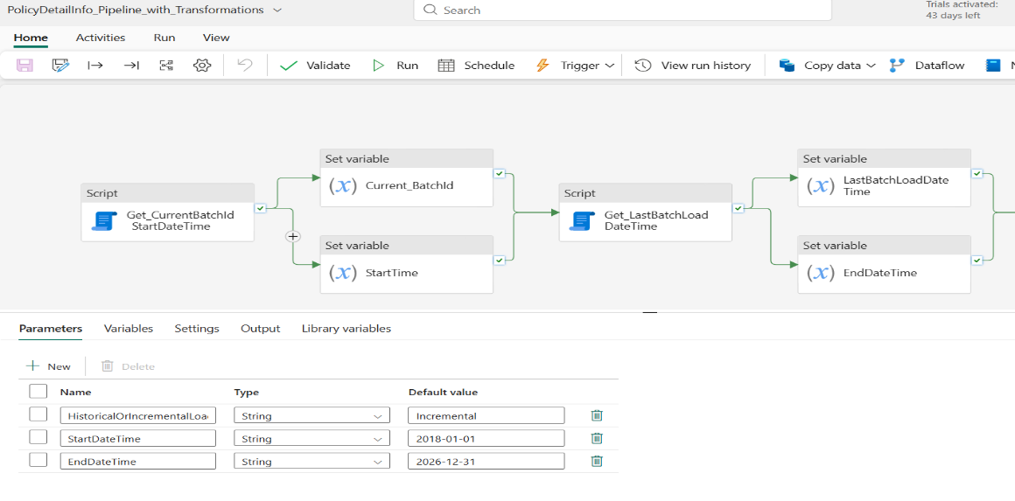

2.2 Loading ID Tables (Before loading Main table- PolicyDetailInfo)
ID Tables Processed:
- Policy.Policy
- Policy.PolicyDetail
- Policy.Transaction
Load Logic :
- Historical Load(True condition inside If Condition activity): Full table copy from Source DB to Stage DB if Stage table has zero records using CopyData activity.
- Incremental Load(False condition inside If condition activity): Fetch MaxID from Stage, insert only records with ID > MaxID from Source to stage using CopyData activity.

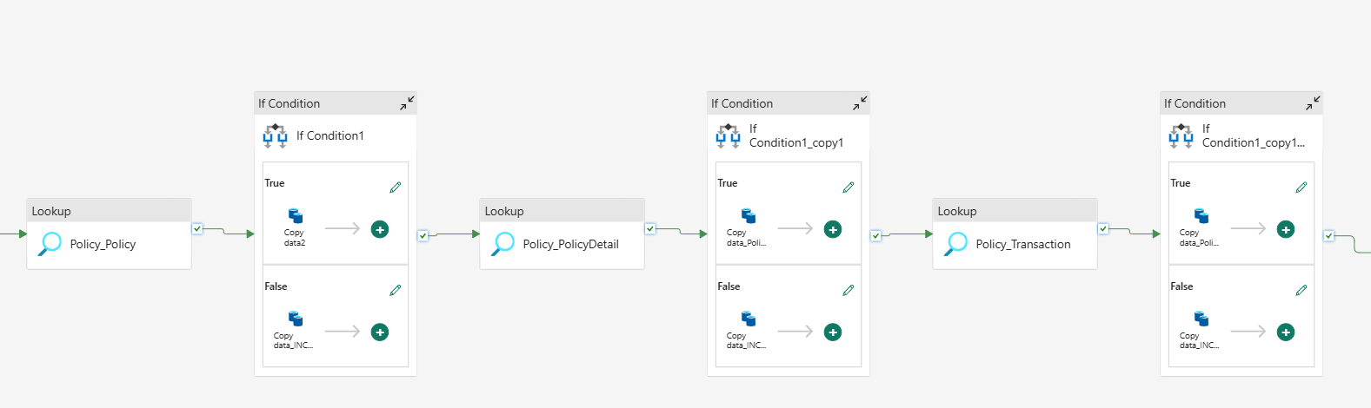

2.3 Loading Main table PolicyDetailInfo:
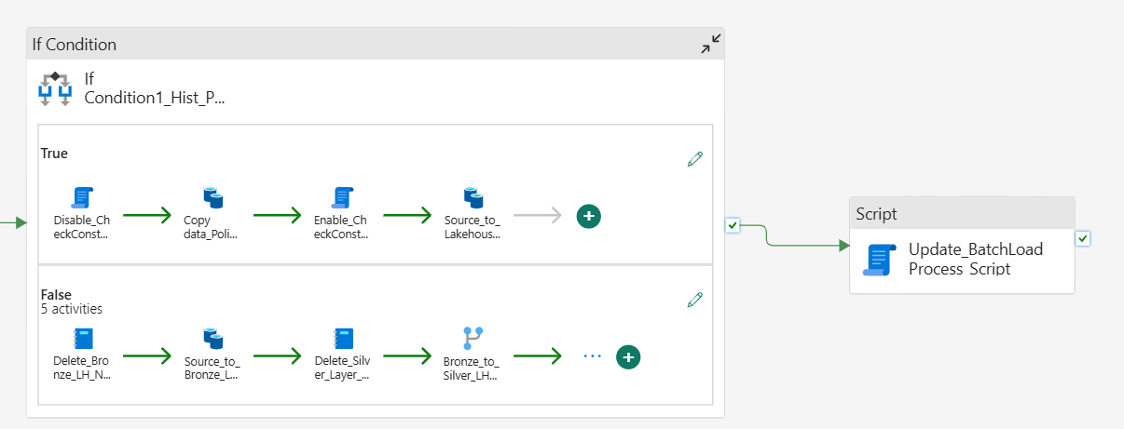

2. 3.1 If Condition Activity – Historical vs Incremental Decision
If Condition Activity : checks if HistoricalOrIncremental parameter value equals to ‘Historical’
- True Condition: Historical Load – Full table copy from Source DB to Stage DB
- False Condition: Incremental Load – Delta records based on ModifiedDateTime from Source to Bronze Lakehouse → Transformed → Stage DB

2.3.5 Batch Process Auditing
- Activity: Script Activity (last activity in flow - named as Update_BatchLoadProcess_Script in pic)
- Operation: Update Batch.Batchloadprocess table
- Action: Set status to Completed, and completion Time calculated using existing stored procedure

